

Mobile Application Development

Lab 8



Muhammad daniyal Qureshi

021-18-0009

BSCS-VII

Contents

Activity 1 MAD Lib Story using Database. 1

**Layout** 1

**Logic Code** 5

**Output** 12

Activity 2:Add Contacts in Database 16

**Layout** 16

**Logic Code** 20

**SQliteOpenHelper Class:** 21

**Output** 23

Activity 3:Create stop watch 26

**Layout** 26

**Logic Code** 27

**Output** 31

Activity 4 Animation Rotation 32

**Layout** 32

**Logic Code** 32

**Output** 35

## Activity 1 MAD Lib Story using Database.

## **Layout**

<?xml version="1.0" encoding="utf-8"?>

<LinearLayout xmlns:android="http://schemas.android.com/apk/res/android"

    xmlns:app="http://schemas.android.com/apk/res-auto"

    xmlns:tools="http://schemas.android.com/tools"

    android:layout_width="match_parent"

    android:layout_height="match_parent"

    android:orientation="vertical"

    tools:context=".MainActivity">

    <ImageView

        android:id="@+id/imageView"

        android:layout_width="match_parent"

        android:layout_height="wrap_content"

        app:srcCompat="@drawable/cover" />

    <TextView

        android:id="@+id/textView"

        android:layout_width="match_parent"

        android:layout_height="wrap_content"

        android:gravity="center"

        android:padding="10dp"

        android:text="Welcome to Mad Libs! I will ask you to fill in words to complete the story until you are done filling in all the missing words. That's part of the fun. Click below to get started..."

        android:textColor="@color/black"

        android:textSize="18sp" />

    <Button

        android:id="@+id/btnst"

        android:layout_width="wrap_content"

        android:layout_height="wrap_content"

        android:layout_gravity="right"

        android:onClick="start"

        android:text="GET STARTED!"

        android:textColor="@color/black"

        android:textSize="30sp"

        android:textStyle="bold"

        android:backgroundTint="#808080"

        />

</LinearLayout>

<?xml version="1.0" encoding="utf-8"?>

<ScrollView xmlns:android="http://schemas.android.com/apk/res/android"

    xmlns:app="http://schemas.android.com/apk/res-auto"

    xmlns:tools="http://schemas.android.com/tools"

    android:layout_width="match_parent"

    android:layout_height="match_parent"

    android:fillViewport="true"

    tools:context=".story">

<LinearLayout

    android:layout_width="match_parent"

    android:layout_height="match_parent"

    android:orientation="vertical"

    >

    <TextView

        android:id="@+id/textView4"

        android:layout_width="wrap_content"

        android:layout_height="wrap_content"

        android:layout_gravity="center"

        android:layout_weight="0"

        android:text="Your Mad Lib Story"

        android:textSize="36sp"

        android:textStyle="bold" />

    <TextView

        android:id="@+id/textView5"

        android:layout_width="match_parent"

        android:layout_height="wrap_content"

        android:layout_weight="0"

        android:text="TextView"

        android:textSize="30sp" />

    <Button

        android:id="@+id/button2"

        android:layout_width="match_parent"

        android:layout_height="wrap_content"

        android:layout_weight="0"

        android:onClick="another"

        android:text="MAKE ANOTHER STORY"

        android:textSize="24sp"

        app:backgroundTint="#808080" />

</LinearLayout>

</ScrollView>

<?xml version="1.0" encoding="utf-8"?>

<LinearLayout xmlns:android="http://schemas.android.com/apk/res/android"

    xmlns:app="http://schemas.android.com/apk/res-auto"

    xmlns:tools="http://schemas.android.com/tools"

    android:layout_width="match_parent"

    android:layout_height="match_parent"

    android:orientation="vertical"

    tools:context=".words">

    <TextView

        android:id="@+id/textView3"

        android:layout_width="wrap_content"

        android:layout_height="wrap_content"

        android:text="Fill in words to complete the story"

        android:textSize="40sp"

        />

    <TextView

        android:id="@+id/leftwords"

        android:layout_width="wrap_content"

        android:layout_height="wrap_content"

        android:textSize="20sp"

        android:layout_gravity="center"

        android:text="TextView"

        android:layout_marginTop="30dp"

        />

<LinearLayout

    android:layout_width="match_parent"

    android:layout_height="wrap_content"

    android:layout_marginTop="20dp"

    >

    <EditText

        android:id="@+id/editext"

        android:layout_width="wrap_content"

        android:layout_height="wrap_content"

        android:ems="10"

        android:inputType="textPersonName"

        android:hint="noun"

        android:layout_marginRight="20dp"

        android:layout_marginLeft="20dp"

        />

    <Button

        android:id="@+id/button"

        android:layout_width="wrap_content"

        android:layout_height="wrap_content"

        android:text="OK"

        android:onClick="Ok"

        android:textColor="@color/black"

        android:backgroundTint="#808080"

        />

</LinearLayout>

    <TextView

        android:layout_width="wrap_content"

        android:layout_height="wrap_content"

        android:layout_gravity="center"

        android:textSize="20sp"

        android:id="@+id/word"

        android:text="please type a/an noun"

        />

</LinearLayout>

## **Logic Code**

package com.example.midlabs;

import android.content.ContentValues;

import android.content.Context;

import android.database.Cursor;

import android.database.sqlite.SQLiteDatabase;

import android.database.sqlite.SQLiteOpenHelper;

import androidx.annotation.Nullable;

public class DBHelper  extends SQLiteOpenHelper {

    public DBHelper(@Nullable Context context, @Nullable String name, @Nullable SQLiteDatabase.CursorFactory factory, int version) {

        super(context, "story.db", factory, 1);

    }

    @Override

    public void onUpgrade(SQLiteDatabase db, int oldVersion, int newVersion) {

        db.execSQL("DROP TABLE IF EXISTS info");

        onCreate(db);

    }

    @Override

    public void onCreate(SQLiteDatabase db) {

        String query="CREATE TABLE info (Number Text,story Text);";

        db.execSQL(query);

    }

    public void insert(String number,String story){

        ContentValues  values=new ContentValues();

        values.put("Number",number);

        values.put("story",story);

        SQLiteDatabase db=getWritableDatabase();

        db.insert("info",null,values);

        db.close();

    }

    public String print(String number){

        String string="";

        SQLiteDatabase db=getWritableDatabase();

        String query="SELECT * FROM info WHERE Number=\""+number+"\";";

        Cursor c=db.rawQuery(query,null);

        c.moveToFirst();

        while (!c.isAfterLast()){

            if(c.getString(c.getColumnIndex("Number"))!=null)

                string+=c.getString(c.getColumnIndex("story"));

            c.moveToNext();

            break;

        }

        db.close();

        return  string;

    }

}

package com.example.midlabs;

import androidx.appcompat.app.AppCompatActivity;

import android.content.Intent;

import android.os.Bundle;

import android.view.View;

public class MainActivity extends AppCompatActivity {

    @Override

    protected void onCreate(Bundle savedInstanceState) {

        super.onCreate(savedInstanceState);

        setContentView(R.layout.activity_main);

    }

    public void start(View view){

        Intent intent=new Intent(this,words.class);

        startActivity(intent);

    }

}

package com.example.midlabs;

import androidx.appcompat.app.AppCompatActivity;

import android.content.Intent;

import android.os.Bundle;

import android.view.View;

import android.widget.TextView;

import org.w3c.dom.Text;

public class story extends AppCompatActivity {

    @Override

    protected void onCreate(Bundle savedInstanceState) {

        super.onCreate(savedInstanceState);

        setContentView(R.layout.activity_story);

        Intent intent=getIntent();

        String story=intent.getStringExtra("story");

        TextView txt=(TextView)findViewById(R.id.textView5);

        txt.setText(story);

    }

    public void another(View view){

        finish();

    }

}

package com.example.midlabs;

import androidx.appcompat.app.AppCompatActivity;

import android.content.Intent;

import android.os.Bundle;

import android.text.TextUtils;

import android.util.Log;

import android.view.View;

import android.widget.EditText;

import android.widget.TextView;

import android.widget.Toast;

import java.util.ArrayList;

import java.util.List;

import java.util.Random;

import java.util.Scanner;

import java.util.regex.Matcher;

import java.util.regex.Pattern;

public class words extends AppCompatActivity {

    TextView leftwords,placingwords;

    EditText editText;

    ArrayList<String> matches;

    String story;

    int counter,index;

    @Override

    protected void onCreate(Bundle savedInstanceState) {

        super.onCreate(savedInstanceState);

        setContentView(R.layout.activity_words);

        Log.i("come","sd");

        leftwords=(TextView)findViewById(R.id.leftwords);

        placingwords=(TextView)findViewById(R.id.word);

        editText=(EditText) findViewById(R.id.editext);

    //insert text

        DBHelper db=new DBHelper(this,null,null,1);

        db.insert("0","One of the most <adjective> characters in fiction is named\n" +

                "\"Tarzan of the <plural-noun> .\" Tarzan was raised by a/an\n" +

                "<noun> and lives in the <adjective> jungle in the\n" +

                "heart of darkest <place> . He spends most of his time\n" +

                "eating <plural-noun> and swinging from tree to <noun> .\n" +

                "Whenever he gets angry, he beats on his chest and says,\n" +

                "\" <funny-noise> !\" This is his war cry. Tarzan always dresses in\n" +

                "<adjective> shorts made from the skin of a/an <noun>\n" +

                "and his best friend is a/an <adjective> chimpanzee named\n" +

                "Cheetah. He is supposed to be able to speak to elephants and\n" +

                "<plural-noun> . In the movies, Tarzan is played by <person's-name> .\n");

        db.insert("1","I wannabe a <job> when I grow up.\n" +

                "Just like my dad.\n" +

                "Life is <adjective> like that!\n");

        db.insert("2","Our American universities offer students many <adjective>\n" +

                "courses that will prepare them to become professional <plural-noun> .\n" +

                "You can get a degree as a Bachelor of <plural-noun> or take a\n" +

                "regular liberal <plural-noun> course. Or, if you want to become\n" +

                "a/an <adjective> engineer, you can study <adjective> mathematics\n" +

                "and differential <plural-noun> . Then, after <number> years, if\n" +

                "you want to continue your studies you can write a/an <noun> and\n" +

                "become a Doctor of <plural-noun> . \n" +

                "\n" +

                "When you get out into the <adjective> world, if you have a diploma \n" +

                "from a university, you will be able to get a job easily as a/an <job-title> \n" +

                "or even a/an <job-title> . If you don't have a diploma, you may have to take\n" +

                "a job as a <noun> . \n" +

                "\n" +

                "Remember, it's important that you study hard in high school so you are able \n" +

                "to do well on your college entrance <plural-noun> . It is true that \"a little \n" +

                "learning is a/an <adjective> thing.\"");

        db.insert("3","<Male-Name> has announced that his <adjective>\n" +

                "clothing store in the heart of downtown <CITY> is having\n" +

                "a/an <adjective> sale of all merchandise, including\n" +

                "<unusual-adjective> suits and slightly irregular <plural-noun>\n" +

                "available. Men's cable-knit <plural-noun> , only $15.99.\n" +

                "Hand-woven Italian <plural-noun> , 1/2-price. Double-\n" +

                "breasted cashmere <plural-noun> , $50.00. Genuine imported\n" +

                "<Color!> <adjective> shoes, <Exciting-adjective> handerchiefs,\n" +

                "and women's embroidered <plural-noun> , all at rock-bottom prices.\n" +

                "This is a chance to get some really <Interesting-Adjective> bargains.\n");

        db.insert("4","Here's how you dance the Monstrosity. Stand with your feet together.\n" +

                "Now, move your left foot <aDvErB> to the side. Now stamp your\n" +

                "right foot <NUMBER> times and put your hands on your partner's\n" +

                "<Plural-Noun> . Next, you both <verb> slowly to the right and bend\n" +

                "your <body-part> backward. For the next eight counts,\n" +

                "both of you <verb> <adverb> to the left. Next, you and\n" +

                "your partner stand back to back and wiggle your <pluRAL-nOUN> and\n" +

                "slap your <plural-noun> together. Don't forget to keep stamping\n" +

                "your right foot. Now, face your partner again, put your <plural-noun>\n" +

                "together and shout, \" <FUNNY-noise> !\" Now, <verb> backward\n" +

                "and repeat the whole thing <Number> times. If you feel that you can't\n" +

                "learn this dance, you can always <verB> the next one out.");

    //Read files

        Random rand=new Random();

        int number=rand.nextInt(5);

        story=db.print(""+number);

// read entire file

          Log.i("val",story);

        Pattern pattern = Pattern.compile("\\<(.*?)\\>");

        Matcher matcher = pattern.matcher(story);

        matches = new ArrayList<String>();

        while(matcher.find())

            matches.add(matcher.group());

        counter=matches.size();

        index=0;

        leftwords.setText(counter +"words(s) left");

        String w=matches.get(index);

        w=w.replace("<","");

        w=w.replace(">","");

        placingwords.setText("please type a/an "+w);

        editText.setHint(w);

        Log.i("dic",matches.toString());

    }

    public  void Ok(View view){

        if(TextUtils.isEmpty(editText.getText().toString()))

        {

            editText.setError("Empty field");

            return;

        }

        Toast.makeText(this,"Great keep  going",Toast.LENGTH_LONG).show();

        leftwords.setText(--counter +"words(s) left");

        String w=matches.get(index);

        story = story.replaceFirst(w, editText.getText().toString());

        if(counter==0)

        {

            Intent intent=new Intent(this,story.class);

            intent.putExtra("story",story);

            startActivity(intent);

        }

        Log.i("story",story);

        w=matches.get(++index);

        w=w.replace("<","");

        w=w.replace(">","");

        placingwords.setText("please type a/an "+w);

        editText.setHint(w);

        editText.setText("");

    }

}

## **Output**

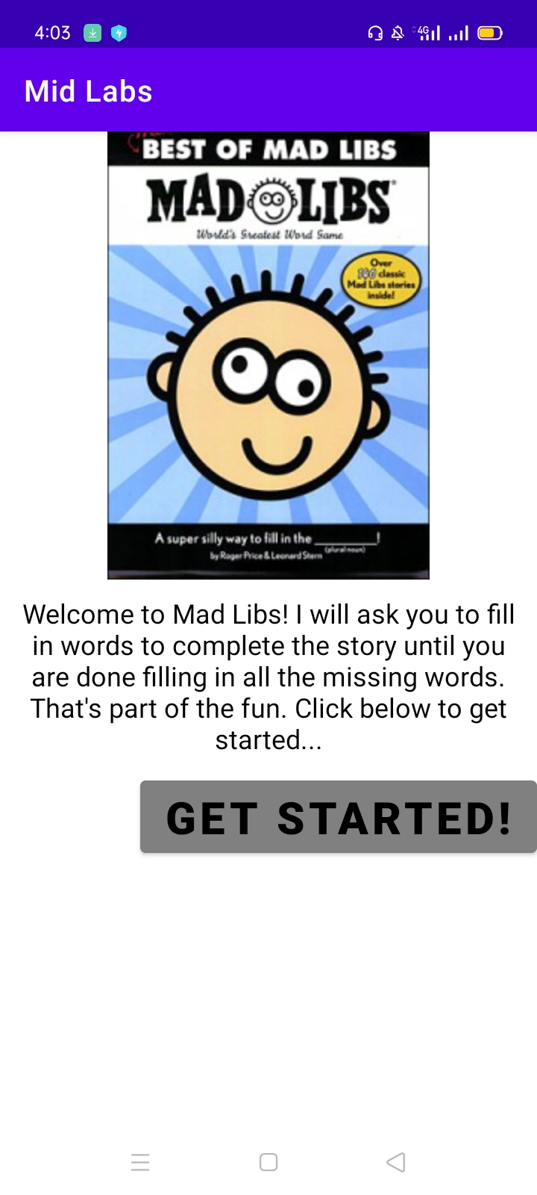

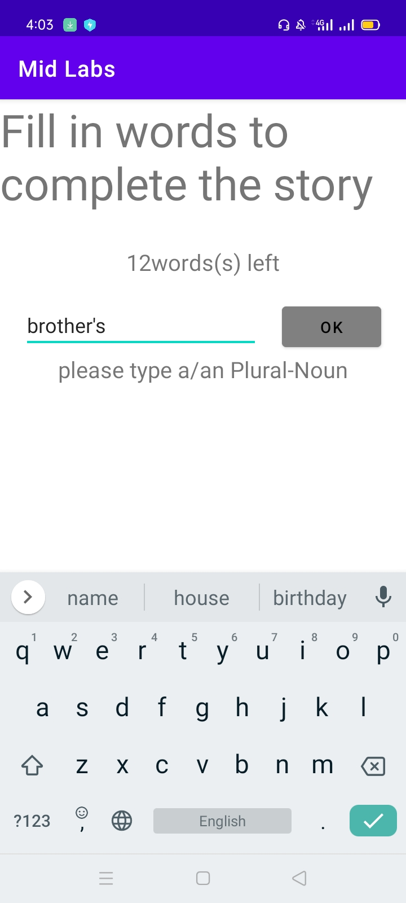

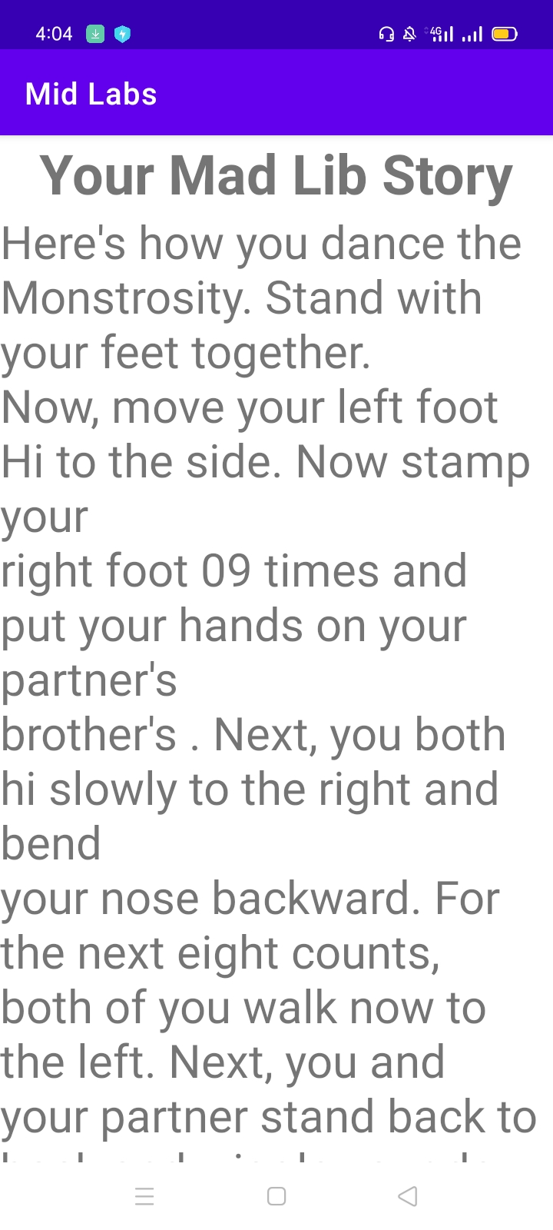

# Activity 2:Add Contacts in Database

## **Layout**

<?xml version="1.0" encoding="utf-8"?>

<LinearLayout xmlns:android="http://schemas.android.com/apk/res/android"

    xmlns:app="http://schemas.android.com/apk/res-auto"

    xmlns:tools="http://schemas.android.com/tools"

    android:layout_width="match_parent"

    android:layout_height="match_parent"

    android:orientation="vertical"

    tools:context=".MainActivity"

    android:padding="30dp"

    >

    <LinearLayout

        android:layout_width="match_parent"

        android:layout_height="wrap_content"

        android:orientation="horizontal"

        android:layout_marginTop="100dp"

        >

        <TextView

            android:layout_width="wrap_content"

            android:layout_height="wrap_content"

            android:layout_weight="0.5"

            android:text="Name" />

        <EditText

            android:id="@+id/text1"

            android:layout_width="wrap_content"

            android:layout_height="wrap_content"

            android:layout_weight="1"

            />

    </LinearLayout>

<LinearLayout

android:layout_width="match_parent"

android:layout_height="wrap_content"

android:orientation="horizontal"

    >

<TextView

    android:layout_width="wrap_content"

    android:layout_height="wrap_content"

    android:layout_weight="0.5"

    android:text="Phone" />

<EditText

    android:id="@+id/text2"

    android:layout_width="wrap_content"

    android:layout_height="wrap_content"

    android:layout_weight="1"

    />

</LinearLayout>

<LinearLayout

android:layout_width="match_parent"

android:layout_height="wrap_content"

android:orientation="horizontal"

    >

<TextView

    android:layout_width="wrap_content"

    android:layout_height="wrap_content"

    android:layout_weight="0.5"

    android:text="Street" />

<EditText

    android:id="@+id/text3"

    android:layout_width="wrap_content"

    android:layout_height="wrap_content"

    android:layout_weight="1"

    />

</LinearLayout>

<LinearLayout

android:layout_width="match_parent"

android:layout_height="wrap_content"

android:orientation="horizontal"

    >

<TextView

    android:layout_width="wrap_content"

    android:layout_height="wrap_content"

    android:layout_weight="0.5"

    android:text="Email" />

<EditText

    android:id="@+id/text4"

    android:layout_width="wrap_content"

    android:layout_height="wrap_content"

    android:layout_weight="1"

    />

</LinearLayout>

<LinearLayout

android:layout_width="match_parent"

android:layout_height="wrap_content"

android:orientation="horizontal"

    >

<TextView

    android:layout_width="wrap_content"

    android:layout_height="wrap_content"

    android:layout_weight="0.5"

    android:text="City/State/Zip" />

<EditText

    android:id="@+id/text5"

    android:layout_width="wrap_content"

    android:layout_height="wrap_content"

    android:layout_weight="1"

    />

</LinearLayout>

<Button

    android:layout_width="wrap_content"

    android:layout_height="wrap_content"

    android:text="Save Contact"

    android:layout_gravity="center"

    android:backgroundTint="@color/teal_700"

    android:onClick="save"

    ></Button>

</LinearLayout>

<?xml version="1.0" encoding="utf-8"?>

<LinearLayout xmlns:android="http://schemas.android.com/apk/res/android"

    xmlns:app="http://schemas.android.com/apk/res-auto"

    xmlns:tools="http://schemas.android.com/tools"

    android:layout_width="match_parent"

    android:layout_height="match_parent"

    android:orientation="vertical"

    tools:context=".database">

    <TextView

        android:layout_width="wrap_content"

        android:layout_height="wrap_content"

        android:layout_gravity="center"

        android:gravity="center"

        android:text="SIBA Database"

        android:textSize="30sp"></TextView>

    <TextView

        android:layout_width="wrap_content"

        android:layout_height="wrap_content"

        android:text="Name : "

        android:id="@+id/name"

        android:padding="30dp"

        ></TextView>

</LinearLayout>

## **Logic Code**

package com.example.addressbook;

import androidx.appcompat.app.AppCompatActivity;

import android.content.Intent;

import android.os.Bundle;

import android.widget.TextView;

public class database extends AppCompatActivity {

    @Override

    protected void onCreate(Bundle savedInstanceState) {

        super.onCreate(savedInstanceState);

        setContentView(R.layout.activity_database);

        Intent intent=getIntent();

        String name=intent.getStringExtra("name");

        TextView text=findViewById(R.id.name);

        DBHelper db=new DBHelper(this,null,null,1);

        text.setText(db.print(name));

    }

}

package com.example.addressbook;

import androidx.appcompat.app.AppCompatActivity;

import android.content.Intent;

import android.os.Bundle;

import android.view.View;

import android.widget.EditText;

public class MainActivity extends AppCompatActivity {

    DBHelper db;

    @Override

    protected void onCreate(Bundle savedInstanceState) {

        super.onCreate(savedInstanceState);

        setContentView(R.layout.activity_main);

        db=new DBHelper(this,null,null,1);

    }

    public void save(View view){

        EditText Name=findViewById(R.id.text1);

        EditText Phone=findViewById(R.id.text2);

        EditText street=findViewById(R.id.text3);

        EditText Email=findViewById(R.id.text4);

        EditText city=findViewById(R.id.text5);

        db.insert(Name.getText().toString(),Phone.getText().toString(),

                street.getText().toString(),Email.getText().toString(),city.getText().toString());

        Intent intent=new Intent(this,database.class);

        intent.putExtra("name",Name.getText().toString());

        startActivity(intent);

    }

}

## **SQliteOpenHelper Class:**

package com.example.addressbook;

import android.content.ContentValues;

import android.content.Context;

import android.database.Cursor;

import android.database.sqlite.SQLiteDatabase;

import android.database.sqlite.SQLiteOpenHelper;

import androidx.annotation.Nullable;

public class DBHelper  extends SQLiteOpenHelper {

    public DBHelper(@Nullable Context context, @Nullable String name, @Nullable SQLiteDatabase.CursorFactory factory, int version) {

        super(context, "SIBA.db", factory, 1);

    }

    @Override

    public void onUpgrade(SQLiteDatabase db, int oldVersion, int newVersion) {

        db.execSQL("DROP TABLE IF EXISTS info");

        onCreate(db);

    }

    @Override

    public void onCreate(SQLiteDatabase db) {

        String query="CREATE TABLE info (Name TEXT,Phone TEXT,Street TEXT,Email TEXT,City Text);";

        db.execSQL(query);

    }

    public void insert(String Name,String Phone,String Street,String Email,String City){

        ContentValues  values=new ContentValues();

        values.put("Name",Name);

        values.put("Phone",Phone);

        values.put("Street",Street);

        values.put("City",Name);

        values.put("Email",Email);

        SQLiteDatabase db=getWritableDatabase();

        db.insert("info",null,values);

        db.close();

    }

    public String print(String name){

        String string="";

        SQLiteDatabase db=getWritableDatabase();

        String query="SELECT * FROM info WHERE Name=\""+name+"\";";

        Cursor c=db.rawQuery(query,null);

        c.moveToFirst();

        while (!c.isAfterLast()){

            if(c.getString(c.getColumnIndex("Name"))!=null)

                string+=c.getString(c.getColumnIndex("Name"));

            c.moveToNext();

            break;

        }

        db.close();

        return  string;

    }

}

## **Output**

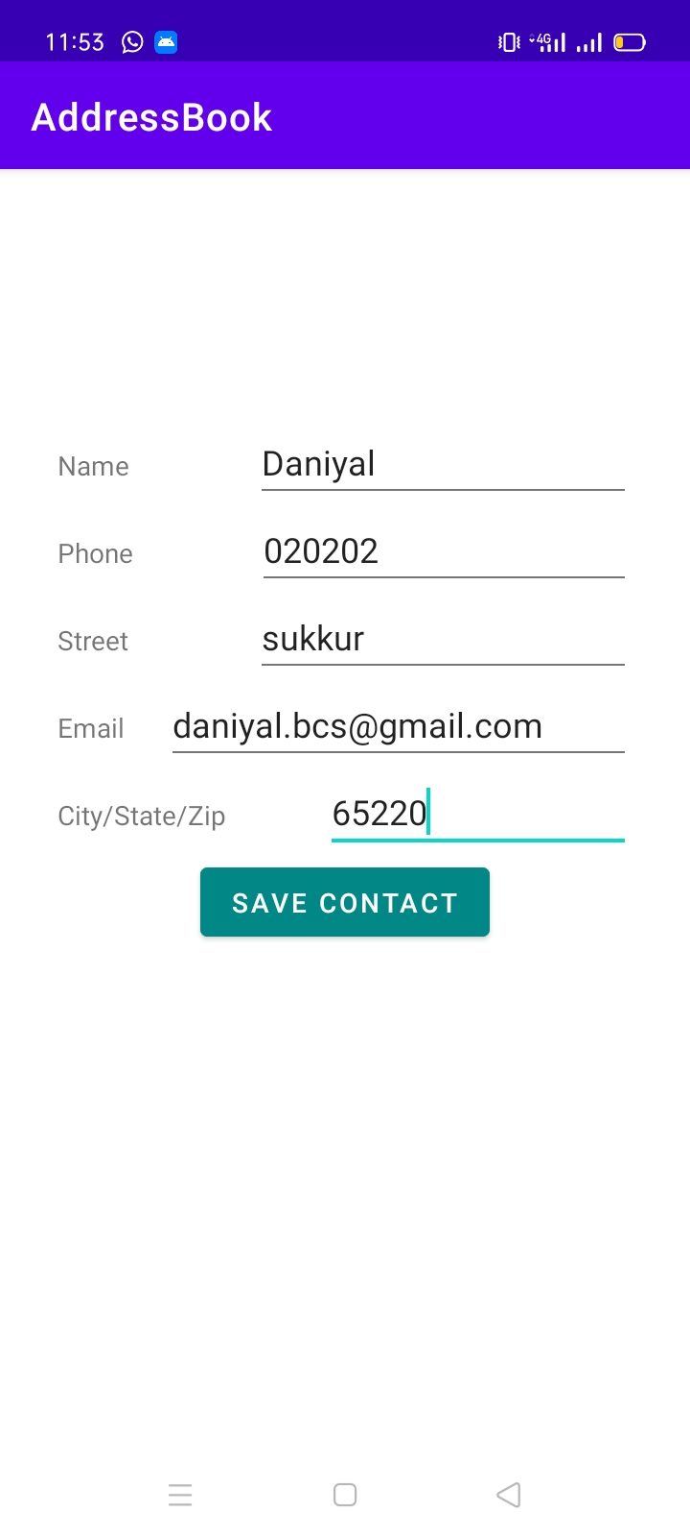

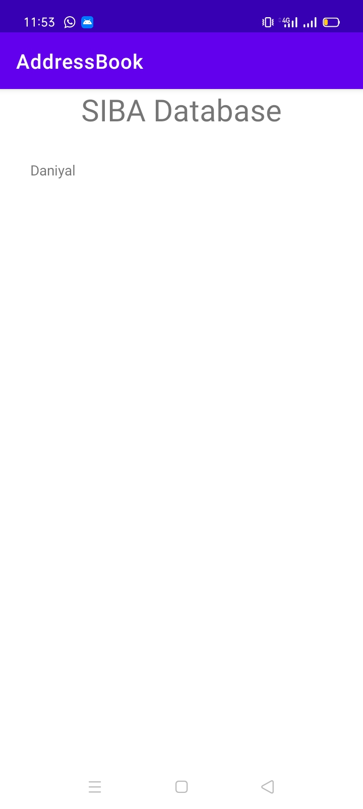

## Activity 3:Create stop watch

## **Layout**

<?xml version="1.0" encoding="utf-8"?>

<RelativeLayout xmlns:android="http://schemas.android.com/apk/res/android"

    xmlns:app="http://schemas.android.com/apk/res-auto"

    xmlns:tools="http://schemas.android.com/tools"

    android:layout_width="match_parent"

    android:layout_height="match_parent"

    tools:context=".MainActivity"

    android:background="@drawable/watch"

    >

<TextView

    android:layout_width="wrap_content"

    android:layout_height="wrap_content"

    android:text="00:00:00"

    android:textSize="70sp"

    android:id="@+id/txt"

    android:layout_centerInParent="true"

    ></TextView>

    <com.google.android.material.button.MaterialButton

        android:layout_width="wrap_content"

        android:layout_height="wrap_content"

        android:text="Start"

        android:id="@+id/start"

        android:textAllCaps="false"

        android:layout_marginBottom="100dp"

        android:layout_alignParentBottom="true"

        android:layout_marginLeft="40dp"

        android:padding="15dp"

        android:textColor="@color/black"

        android:textSize="20sp"

        android:backgroundTint="#808080"

        android:onClick="Start"

        ></com.google.android.material.button.MaterialButton>

    <com.google.android.material.button.MaterialButton

        android:layout_width="wrap_content"

        android:id="@+id/stop"

        android:layout_height="wrap_content"

        android:text="Stop"

        android:onClick="Stop"

        android:textAllCaps="false"

        android:layout_marginBottom="100dp"

        android:layout_alignParentBottom="true"

        android:layout_marginLeft="150dp"

        android:padding="15dp"

        android:textColor="@color/black"

        android:textSize="20sp"

        android:backgroundTint="#808080"

        ></com.google.android.material.button.MaterialButton>

    <com.google.android.material.button.MaterialButton

        android:id="@+id/reset"

        android:layout_width="wrap_content"

        android:layout_height="wrap_content"

        android:text="Reset"

        android:textAllCaps="false"

        android:layout_marginBottom="100dp"

        android:layout_alignParentBottom="true"

        android:layout_marginLeft="260dp"

        android:padding="15dp"

        android:textColor="@color/black"

        android:textSize="20sp"

        android:onClick="Reset"

        android:backgroundTint="#808080"

        ></com.google.android.material.button.MaterialButton>

</RelativeLayout>

## **Logic Code**

package com.example.stopwatch;

import androidx.annotation.NonNull;

import androidx.appcompat.app.AppCompatActivity;

import android.os.Bundle;

import android.os.Handler;

import android.view.View;

import android.widget.TextView;

import java.util.Locale;

public class MainActivity extends AppCompatActivity {

    private int seconds = 0;

    // Is the stopwatch running?

    private boolean running;

    private boolean wasRunning;

    @Override

    protected void onCreate(Bundle savedInstanceState) {

        super.onCreate(savedInstanceState);

        setContentView(R.layout.activity_main);

        if (savedInstanceState != null) {

            seconds

                    = savedInstanceState

                    .getInt("seconds");

            running

                    = savedInstanceState

                    .getBoolean("running");

            wasRunning

                    = savedInstanceState

                    .getBoolean("wasRunning");

        }

        runTimer();

    }

    @Override

    protected void onSaveInstanceState(@NonNull Bundle savedInstanceState) {

        super.onSaveInstanceState(savedInstanceState);

        savedInstanceState

                .putInt("seconds", seconds);

        savedInstanceState

                .putBoolean("running", running);

        savedInstanceState

                .putBoolean("wasRunning", wasRunning);

    }

    @Override

    protected void onPause() {

        super.onPause();

        wasRunning = running;

        running = false;

    }

    @Override

    protected void onResume() {

        super.onResume();

        if (wasRunning) {

            running = true;

        }

    }

    public void Start(View view)

    {

        running = true;

    }

    public void Stop(View view)

    {

        running = false;

    }

    public void Reset(View view)

    {

        running = false;

        seconds = 0;

    }

private void runTimer() {

        // Get the text view.

        final TextView timeView

                = (TextView) findViewById(

                R.id.txt);

        // Creates a new Handler

        final Handler handler

                = new Handler();

        handler.post(new Runnable() {

            @Override

            public void run() {

                int hours = seconds / 3600;

                int minutes = (seconds % 3600) / 60;

                int secs = seconds % 60;

                // Format the seconds into hours, minutes,

                // and seconds.

                String time

                        = String

                        .format(Locale.getDefault(),

                                "%d:%02d:%02d", hours,

                                minutes, secs);

                // Set the text view text.

                timeView.setText(time);

                // If running is true, increment the

                // seconds variable.

                if (running) {

                    seconds++;

                }

                // Post the code again

                // with a delay of 1 second.

                handler.postDelayed(this, 1000);

            }

        });

    }

}

## **Output**

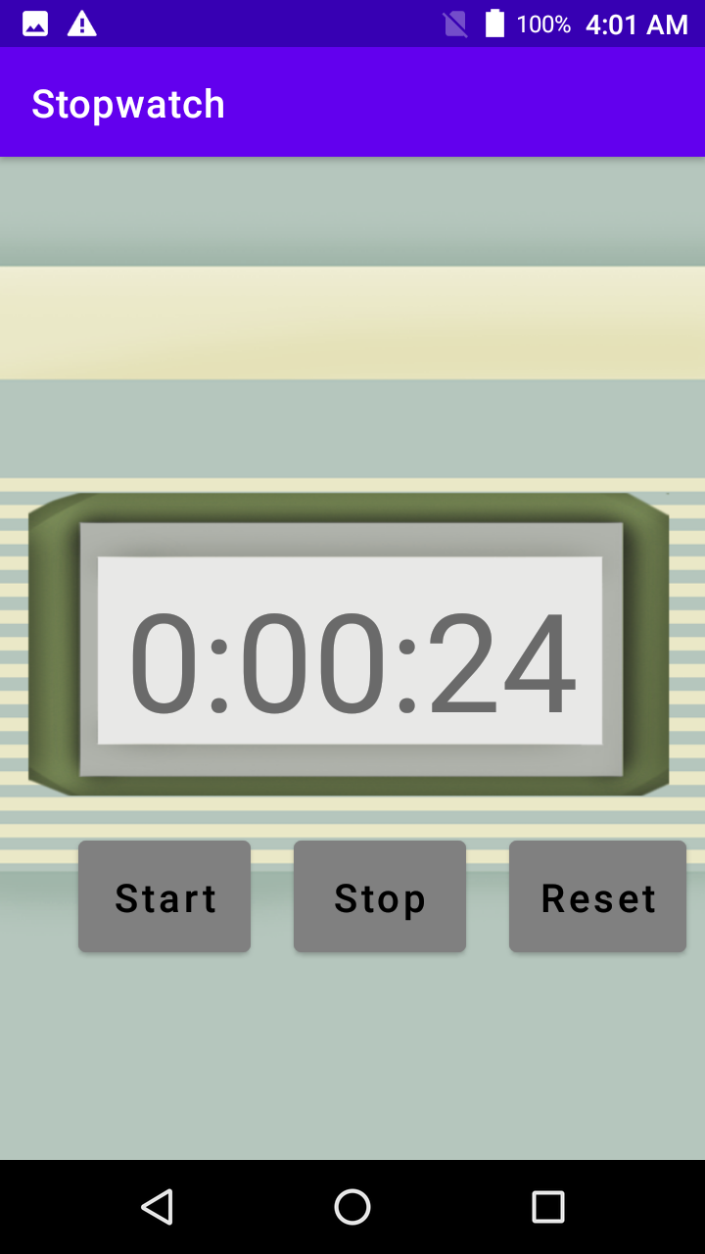

## Activity 4 Animation Rotation

## **Layout**

<?xml version="1.0" encoding="utf-8"?>

<androidx.constraintlayout.widget.ConstraintLayout xmlns:android="http://schemas.android.com/apk/res/android"

    xmlns:app="http://schemas.android.com/apk/res-auto"

    xmlns:tools="http://schemas.android.com/tools"

    android:layout_width="match_parent"

    android:layout_height="match_parent"

    tools:context=".MainActivity">

    <ImageView

        android:id="@+id/imageView"

        android:layout_width="100dp"

        android:layout_height="100dp"

        android:layout_marginStart="140dp"

        android:layout_marginLeft="140dp"

        android:layout_marginTop="50dp"

        app:layout_constraintStart_toStartOf="parent"

        app:layout_constraintTop_toTopOf="parent"

        app:srcCompat="@drawable/im" />

    <Button

        android:id="@+id/button2"

        android:layout_width="0dp"

        android:layout_height="wrap_content"

        android:layout_marginTop="84dp"

        android:onClick="toggle"

        android:text="toggle rotate"

        android:textColor="#330505"

        android:textSize="16sp"

        app:backgroundTint="#BFB7B7"

        app:layout_constraintEnd_toEndOf="parent"

        app:layout_constraintStart_toStartOf="parent"

        app:layout_constraintTop_toBottomOf="@+id/imageView" />

</androidx.constraintlayout.widget.ConstraintLayout>

## **Logic Code**

package com.example.rotateanimation;

import androidx.appcompat.app.AppCompatActivity;

import android.content.SharedPreferences;

import android.os.Bundle;

import android.util.Log;

import android.view.View;

import android.widget.ImageView;

public class MainActivity extends AppCompatActivity {

    int counter=0;

    Boolean check;

    ImageView img;

    @Override

    protected void onCreate(Bundle savedInstanceState) {

        super.onCreate(savedInstanceState);

        setContentView(R.layout.activity_main);

        SharedPreferences pref=getSharedPreferences("c",MODE_PRIVATE);

        img=findViewById(R.id.imageView);

        check=true;

            counter=pref.getInt("counter",0);

        img.setRotation(counter);

    }

    public void toggle(View view) {

        SharedPreferences pref=getSharedPreferences("c",MODE_PRIVATE);

        SharedPreferences.Editor editor=pref.edit();

        if(check) {

            editor.putInt("counter",counter);

            editor.commit();

            check = false;

        }

        else

            check=true;

        Thread thread=new Thread(new Runnable() {

            @Override

            public void run() {

             while(check){

                counter+=20;

                 if(counter==360)

                     counter=0;

                 img.setRotation(counter);

                 try {

                     Thread.sleep(50);

                 } catch (InterruptedException e) {

                     e.printStackTrace();

                 }

             }

            }

        });

        thread.start();

    }

}

## **Output**

